Q. how to break the root mirroring in hpux?

Answer.

1. Identify the current mirror boot drives. By default LVM bootable mirror volume group is "/dev/vg00". Use "strings" and "vgdisplay" commands.

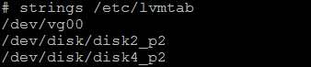

1. Check vgdisplay & identify the disk which removed from mirrored

#vgdisplay –v vg00

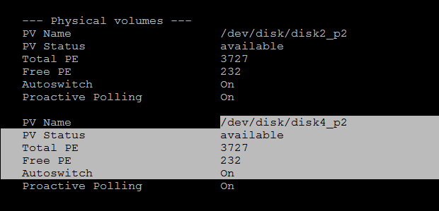

1. Reduce the physical volume mirror from the logicals volumes in reverse order using "lvreduce -m - /dev/vg00/lvol## /dev/dsk/c#t#d#" command. Remember to specific the physical volume that will be removed.

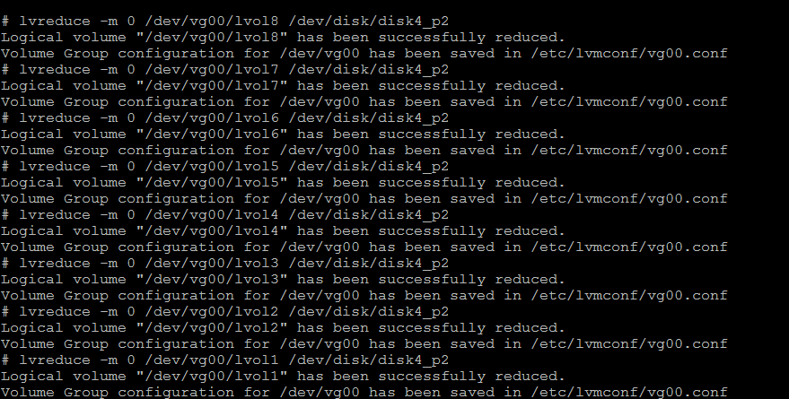

4 .check vgdisplay & find le size & pe size was same its mean mirroring was break

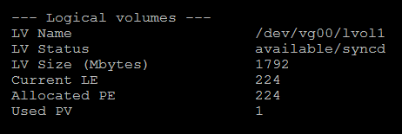

5.Reduce the physical volume from the volume group using "vgreduce /dev/vg00 /dev/dsk/c#t#d0" command. Remember to specific the physical volume that will be removed.



6. Finally remove LVM headers from the physical volume using "pvremove /dev/rdsk/c#t#d#" command. Remember to use the character (raw) device special file.

